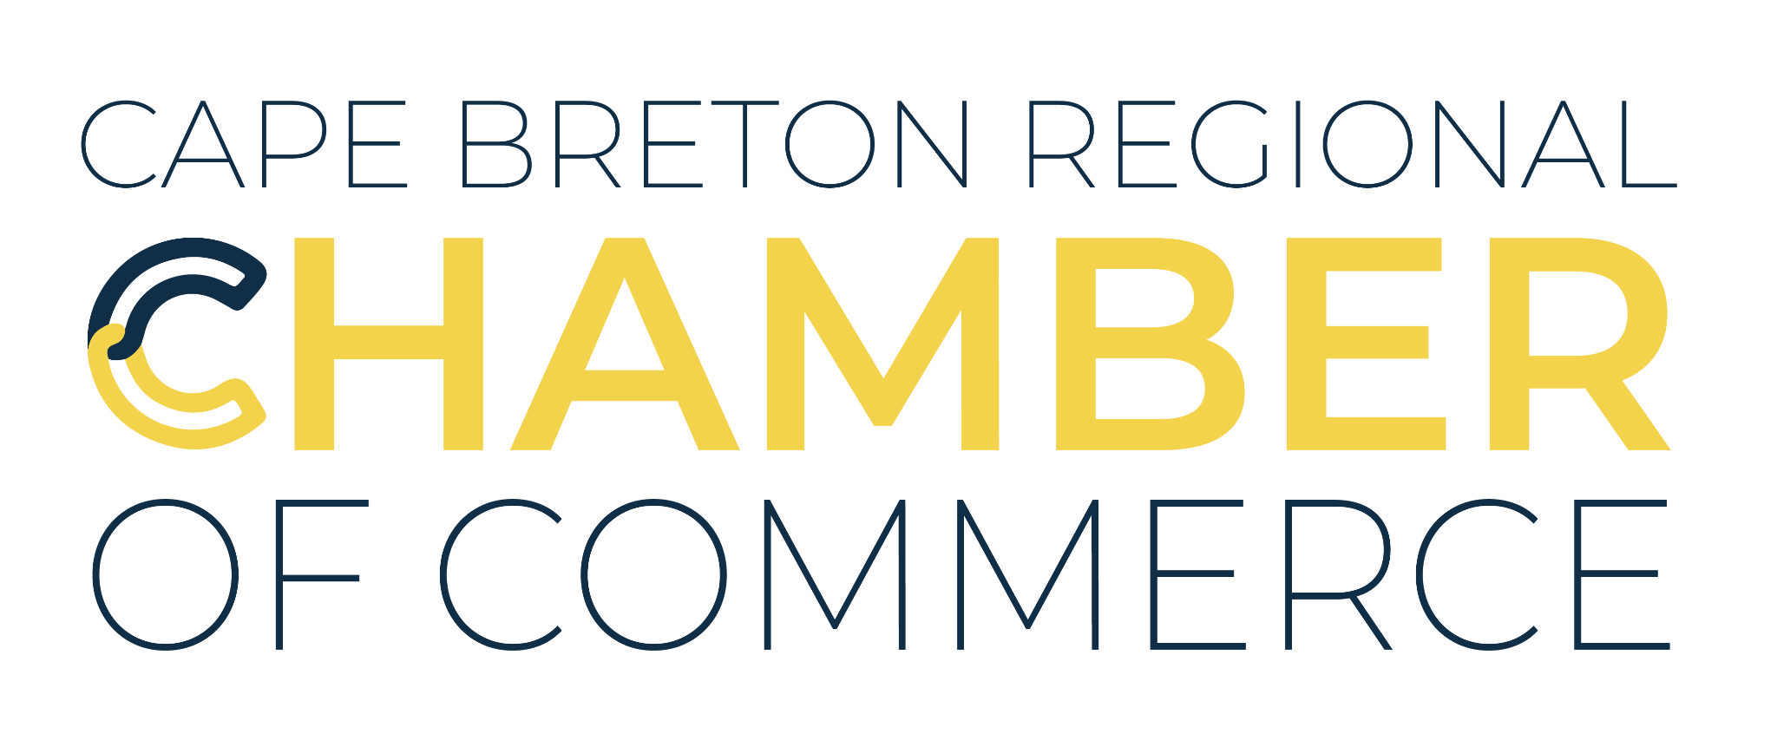

The Cape Breton Regional Chamber of Commerce is seeking a dynamic professional to fill the full-time position of Membership and Events Coordinator.

**About Us:**

The Chamber’s mission is to empower businesses to thrive in the CBRM. We cultivate positivity by shifting the conversation around business while strengthening our community through collaboration, networking, advocacy, and education. Acting in the best interests of our members, we embrace change, foster innovation, and advocate for business growth throughout the CBRM. Leading with transparency, accountability, and integrity, we create opportunities for businesses to connect, grow, and succeed.

**Description:**  
As the Membership and Events Coordinator, you will play a crucial role in enhancing the Chamber’s membership experience and ensuring the success of our events. You will lead efforts to recruit and retain members, provide support and integration into Chamber programs, and manage the planning and execution of various events. This role requires creativity, strong organizational skills, and the ability to work both independently and collaboratively.

**You Are:**

* Outgoing and motivated to succeed in a professional environment.
* Excelling in creative and encouraging work environments.
* A self-starter who thrives in a team setting.
* Passionate about supporting and advancing our business community.

**Responsibilities:**

* Lead projects to support current and future Chamber members and drive membership recruitment and retention efforts.
* Develop and implement a Membership Retention and Recruitment Communications Strategy.
* Host webinars, Chamber 101 sessions, and other member benefit services.
* Create and publish member profiles on social media and in newsletters.
* Manage dues collection, invoicing, and member payment reminders.
* Oversee logistics of Chamber events, including planning, execution, and post-event evaluations.
* Collaborate with the team on event themes, materials, marketing initiatives, and promotion.
* Write event program documents, including scripts, agendas, schedules, and signage.
* Collect and create event content, including program information and descriptions.
* Liaise with event stakeholders and sponsors, ensuring sponsorship deliverables are met.
* Update website event pages and event registration database.

**Qualifications:**

* Degree or Diploma in Business, Communications, Marketing, Public Relations, or equivalent experience.
* Knowledge of communications and marketing ethics and best practices.
* Strong time-management and organizational skills, with the ability to meet deadlines.
* Exceptional writing and interpersonal communication skills.
* Ability to work both independently and as part of a team.
* Proficiency with computer software (e.g., Microsoft Suite, Google Docs, Google Drive).
* This position is subsidized through the Graduate to Opportunity (GTO) program. To be eligible, candidates must have graduated within the past year with a degree or diploma.

**Salary:** $45,000 (subject to negotiation based on qualifications)

**Closing Date:** April 15, 2025

*The Cape Breton Regional Chamber of Commerce is an equal opportunity employer. It is the Chamber’s policy to recruit, hire, and promote people in all job classifications without regard to race, gender, age, religion, national origin, disability, marital status, or sexual orientation.*